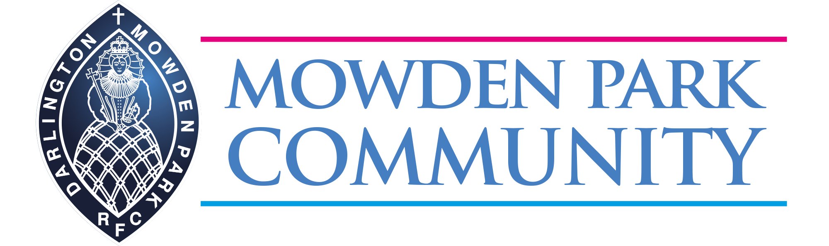

The Darlington Mowden Park Community Scheme has teamed up with Create Development to provide real PE sector leading training for teachers.

The aim is to inspire positive changes in primary aged children’s relationship with and participation in physical activity. The Community Scheme is now into its 6th year and has already delivered programmes and initiatives to over 50,000 children and young people in 75+ schools, colleges and community groups across the North East.
real PE is a unique, holistic approach to teaching and learning. It provides fun and simple Schemes of Work and support for primary school teachers that give them the confidence and skills to deliver outstanding PE. Fully aligned to the National Curriculum and Ofsted requirements, real PE focuses on the development of agility, balance, coordination, healthy competition and cooperative learning.
Phill O'Brien, Regional Manager of Create Development, commented: "We are super excited to be partnering with Darlington Mowden Park. Our shared values of whole child development, their links into the schools community and our experience of supporting tens of thousands of teachers in over 5000 schools on a journey to outstanding teaching and learning through physical education is an exciting opportunity for the teachers and children in primary schools in the area."
We will be hosting a Real PE information session on Thursday 19th September, to discuss the real PE programme and the impact it will have on your school. Local evidence will be shared to highlight the positive changes that have taken place during the past academic year, from staff attitudes to PE, pupil enjoyment and feedback and a whole system approach to PE and School Sport.
Thursday 19th September
3 slots available:
A. 7.30-8.30am
B. 12pm-1pm
C. 3.30pm-4.30pm
Refreshments will be provided at each session.
If you’re interested in attending, please book by contacting Anne Rose – Community Manager by email: community@mowdenpark.com or call 01325 350267

The real PE programme is supported by Jasmine - your real learning platform to simplify, streamline and enhance your real PE experience. This teaching and learning aid is intuitive and easy to navigate enabling teachers to plan and deliver an outstanding PE lesson with confidence.
The 4 Day Training is taking place on the following dates:-
- Day 1: Thursday 14th November 2019 (12noon - 3.00pm)
- Day 2: Thursday 9th January 2020 (12noon - 3.00pm)
- Day 3: Thursday 12th March 2020 (12noon - 3.00pm)
- Day 4: Thursday 14th May 2020 (12noon - 3.00pm)
Venue: Northern Echo Arena, Neasham Road, Darlington, County Durham DL2 1DL

Cost: £495 plus VAT includes
- 4-days training (split over the school year)
- Unrivalled supporting resources
- Ongoing support
- Access to Jasmine – your real learning platform (one-year licence) which includes:
- Assessment framework and tools
- Fully aligned curriculum map
- A Scheme of Work for your year group
- 36 weeks of interactive Lesson Plans
- Integrated videos
- Supporting tools and documents

Jasmine annual licence costs after year 1 (for your chosen year group): £145 plus VAT

OR Whole School annual licence costs:
- Average school: £245 plus VAT
- Small school (100 pupils or less): £145 plus VAT
- Large school (21 classes +): £345 plus VAT

Booking:
Please contact Anne Rose at community@mowdenpark.com or on 01325 350267 to book your place or for more information.

Create Development is redefining what’s possible for PE and Sport. They have trained over 21,000 practitioners at over 4,500 schools, impacting on over 1.5 million children. Their innovative training and unique resources support schools, families and communities to transform the culture of physical activity.
Creating positive relationships with physical activity for life.

Level 5/6 Physical Education at Mowden Park

Details and dates for the upcoming Level 5 Certificate in Primary School Physical Education Specialism
Mowden Park in the Community are pleased to announce the dates for the Level 5 Certificate in Primary School Physical Education Specialism course. Commencing in October 2019, the course will be delivered over six days and will give you all the tools to be ready for the new Ofsted framework.
You will learn how to implement an outstanding curriculum and be able to measure its impact. The course is an effective and sustainable use of the Primary PE and Sport Premium and will help you demonstrate the lifelong impact the premium funding has had on your school with whole school improvement.
Level 5 Certificate in Primary School Physical Education Specialism
The Level 5 Certificate in Primary School Physical Education Specialism is a recognised qualification that aims to upskill primary school teachers, higher level teaching assistants and teaching assistants with extensive experience (experience across year groups and pupil groups) to improve the overall delivery of the physical education curriculum within primary schools. On successful completion of this qualification, delegates will be able to assist in raising the standards within primary school physical education teaching.
The qualification teaches delegates how to understand the requirements of the primary school physical education curriculum, the links between the principles of pedagogy and child development and how using a range of activities can impact on ‘good or better’ teaching and learning within primary school physical education.
Delegates will also learn how to develop plans for units of work that cover the primary school physical education curriculum and that use assessment to impact on learning and progress. Delegates will deliver, teach, evaluate and review the plans for units of work and will learn how to use the outcomes of the unit of work to inform future planning.
Level 6 Award in Primary School Physical Education Subject Leadership
The Level 6 Award in Primary School Physical Education Subject Leadership is a recognised qualification to improve the overall delivery of the physical education curriculum within the primary schools. The aim of this qualification is to up skill primary school teachers to enable them to lead the delivering of the primary school physical education curriculum. On successful completion of this qualification, delegates will be able to advocate, articulate and lead physical education to achieve whole school improvement.
Both courses are written by the Association for Physical Education (afPE) which is the only representative PE Subject Association in the UK. The courses are accredited by Sports Leaders UK.
Why should delegates undertake the qualifications?
The aim of the qualifications is to upskill primary colleagues to be able to assist (Level 5) or lead (Level 6) the delivery of high-quality primary school PE. These qualifications are proven, effective use of the Primary PE and Sport Premium funding and are designed to help teachers and primary school staff deliver high quality, sustainable PE as part of the curriculum.
Who are these qualifications for?
Delegates must fit the following criteria:
 | Level 5 | Level 6
Primary school teacher with QTS or GTCS | ✓ | ✓
Primary school teacher without QTS or GTCS | ✓* | X
Higher level teaching assistant within a primary school | ✓* | X
Teaching assistant with 2 years’ experience delivering PE across both Key Stage 1 and 2 | ✓* | X
Secondary school teacher |  | X
Further education lecturer |  | X
Coach** working within a primary school in the role as a Teaching Assistant (should have a minimum of 5 years’ experience delivering PE across both Key Stage 1 and 2) | ✓* | X
Employee of an external organisation linked to a primary school |  | X
*On completion of the qualification these individuals will be PE specialists – they are still required to be supervised by a QTS accredited teacher in their role in raising the standards of PE teaching. This qualification does not qualify individuals to become a PE teacher.
**Coaches are still required to have a minimum of a Level 2 qualification in any of the sports/activities that they assist in raising the standards of PE teaching.
Key Outcomes
- Guaranteed to increase delegates’ confidence, competence and PE subject knowledge
- Proven to raise standards across the curriculum and contribute to whole school improvement
- Effective and sustainable use of the Primary PE and Sport Premium
These are professional degree equivalent level qualifications.
Location, Time, Commitment, Dates
The courses are delivered from the Northern Echo Arena in Darlington, home of Darlington Mowden Park RFC. The Level 5 course is delivered over 6 days, face to face with a tutor. The Level 6 course is a further 2 days with a tutor.
A buffet lunch and refreshments are provided for each delegate on the course.
The cost of the courses are:
Level 5
*£850 Mowden Park Community Partner Organisation
*£1000 Non-Mowden Park Community partner Organisation
Level 6
*£275
*All costs are exclusive of VAT
Dates:
- 15th October 2019
- 13th November 2019
- 15th January 2020
- 11th February 2020
- 4th March 2020
- 24th March 2020
For more information or to book your place on one of these great courses, email community@mowdenpark.com or call us on 01325 350267.

