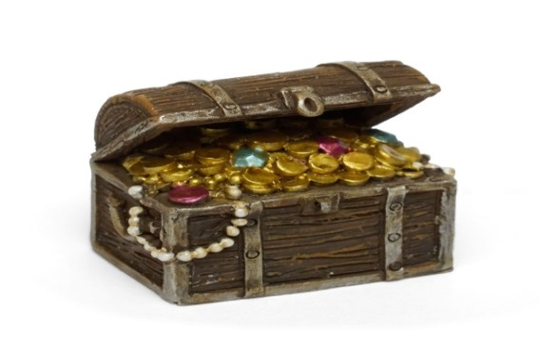
Community Grant Fund
Small Grants
Application Form & Criteria

If you need help completing this form call Sharon on 01642 729309

We want to hear your ideas about what you can do to make Middlesbrough a better place to live, work and visit.
Middlesbrough Council wants to make the town a better place and want to support local people, voluntary, faith and community groups with money to help them pay for their ideas to make this happen.
You can ask for the money by:
- sending in your application by email or post by filling in this form;
- sending in a video or sharing your idea via social media;
- calling us on the phone and talking to us.
Try to answer all of the following questions but don’t worry if you’re not sure what to put as we will ring or email you if we have any questions. Please read the criteria at the bottom of the form before answering any of the questions.

THIS GRANT IS ONLY FOR THOSE RESIDENT LED OR COMMUNITY GROUPS WITHOUT A CONSTITUTION OR GROUP BANK ACCOUNT. IF THESE ARE IN PLACE PLESE REFER TO THE COMMUNITY CHEST GRANT PROGRAMME.

We are looking for projects of varying sizes, from as little as £20 up to £1500, which meet one (or more) of our six priorities to help make life better for residents:
- Help people get ready for work, or find better jobs

- Help people to learn new things

- Make people feel healthier or happier

- Make outdoor spaces better

- Bringing different people together

- Improve what people think of Middlesbrough and help people aim higher

Please indicate which priority best fits with your proposal
4
5
6
2
3
1
In advance of completing the rest of this application, we suggest you read the criteria at the bottom of this form.
Your information

Your name

Your address, telephone number and email address

Please make sure you give all!

What do you want to do?

How will this help?

Have you discussed this with others?
How much money do you need? | What will you spend it on | Cost
 | Total | £
 | Amount requested from us | £
 | If the amount requested is lower than the total project cost detail how the balance is being met
What difference do you think the funding will make?

Declaration
I confirm that the statements contained in this application are correct
Middlesbrough Council reserves the right to withdraw or recover any grant aid awarded in the event of non-compliance with the terms and conditions of the grant aid.
All applications must be signed and dated.

Signature Date

All funding applications must be returned by email to: Sharon Barker, Voluntary Sector Liaison & Grants Officer: sharon_barker@middlesbrough.gov.uk
If you don’t have access to email please ring 01642 729309 and arrangements will be made for you to deliver the application form in person.

Middlesbrough Council
Community Grant Fund Small Grants
– Criteria

We want to hear your ideas about what you can do to make Middlesbrough a better place to live, work and visit.
We will call what you want to do a project. Your project can be big or small depending on what you want to do but must cover one of the six priorities shown on the front page. Successful projects will have high involvement and ownership by the community.
- Applicants must be over 16 years of age.

- This grant fund is only available to resident and small community groups based in Middlesbrough.

- You do not need to be constituted or have a group/project bank account to apply for this funding; arrangements are in place for those groups of people who do not have the latter to have access to one. Those groups that do have these in place should access this fund through the Community Chest application process.

- Funding is to make a difference to local areas and people, so can fund anything you feel can do that, from equipment to activity.

- Funding cannot be used to fund:
  - Constituted groups
  - Things to benefit only you as an individual
  - Activity promoting religious beliefs
  - Trips outside of Middlesbrough
  - Uniformed groups or football teams
  - Money to keep things running (that can use one of our other grant programmes)
  - Illegal activity or one not meeting government restrictions
  - Food

- You can apply for grants from £20 to £1500.

- Once your project is finished you can apply for more money to run a different project if money is still available.

- You will have to show the council how you have spent the money and tell us what you have done. Any money not spent by the end of the project will need to be returned.

- Projects working with vulnerable adults or children must have the appropriate safeguarding policy in place. Support is available to help you with this.

- Projects will be involved in a big publicity campaign run by the Council communications team. Please note you must inform any members of your group/participants in publicity of the council’s privacy notice, see below.

- Privacy notice – https://www.middlesbrough.gov.uk/mayor-council-and-councillors/about-council/privacy-notices/privacy-notice-community-grant

- Marketing: Middlesbrough Council may contact you in the future about other grant programmes, training, events or other information of interest. Please indicate here if you are happy to receive this information

If you want to speak to me or need any help please either ring me on 01642 729309 or email sharon_barker@middlesbrough.gov.uk

