

**64.8%** adult population participate in more than 150 mins of physical activity each week. 1

**25.2%** adult population participate in less than 30 mins of physical activity each week. 1

**ACTIVE**

**9.9%** adult population participate in 30 to 149 mins of physical activity each week. 1

**FAIRLY ACTIVE**

**INACTIVE**

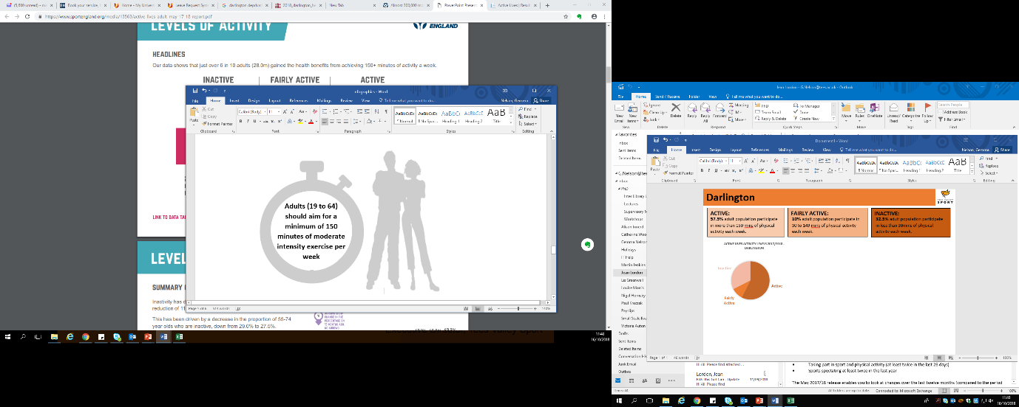

**15.9% of adults living in Redcar & Cleveland have volunteered to support sport and physical activity at least twice in the last year (Nov 18/19) compared to 17.7% the previous year. 1**

25.2%27.8

64.8%

9.9%

2

Adults doing more than 150 mins a week 1

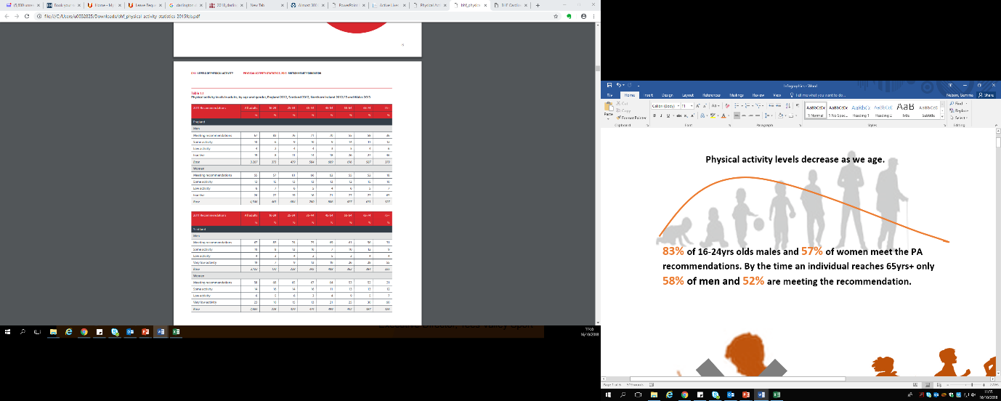

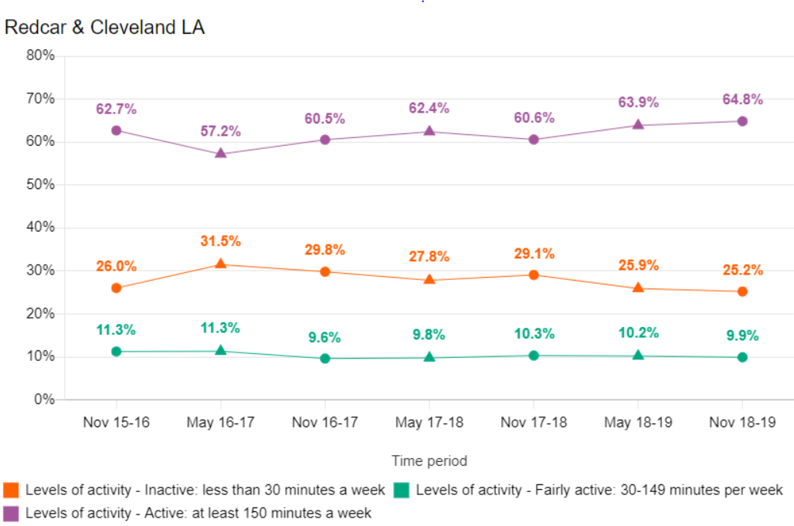

3

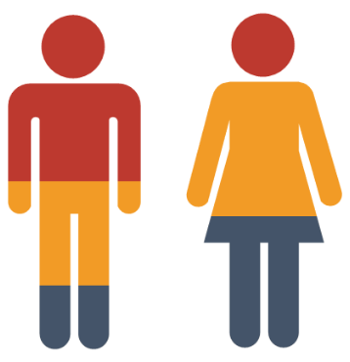

Population mid 2017 6

Total 135,300

Males 69,500

Females 65,800

Life expectancy is **10** years lower for men and **5.7** years lower for women in the most deprived areas of Redcar & Cleveland than in the least deprived areas. 5

About **26%** (6,400) of children live in low income families in Redcar & Cleveland.  5

**Key influencers and impact of low physical activity**

In Year 6, **21.2%** (299) of children are classified as obese, worse than the average for England of 20%. 5

**70.9%** of adults are classified as overweight or obese. 5

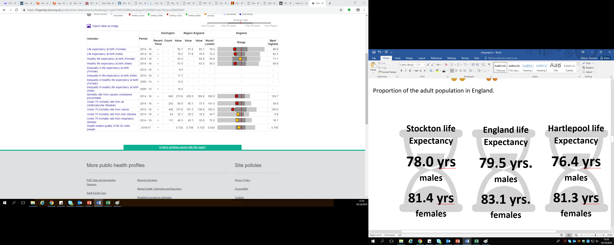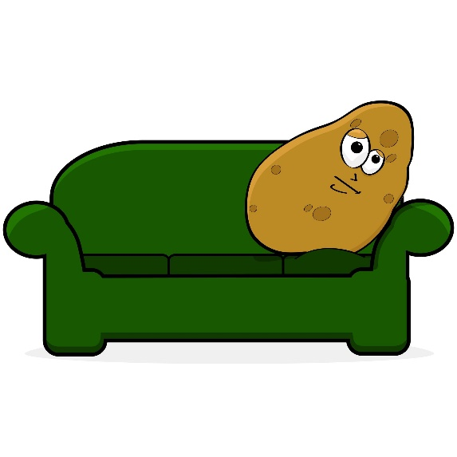

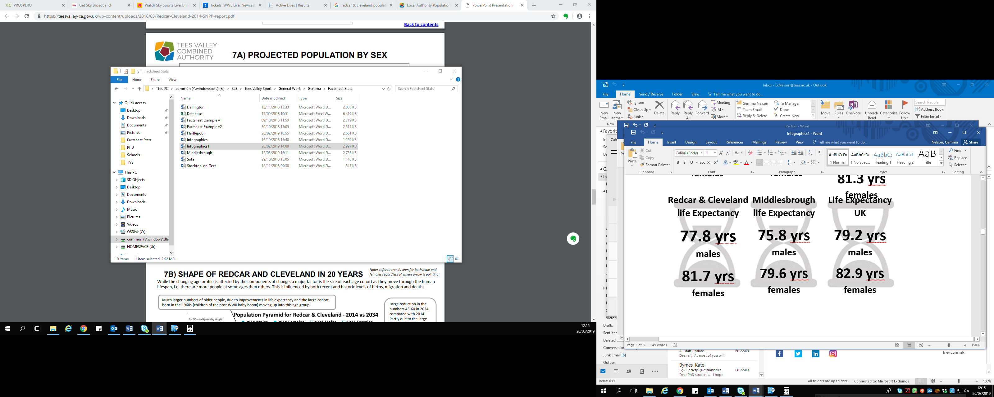

5

The unemployment claimant rate in September 2018 in Redcar & Cleveland was 6.6% compared to the national rate of 2.2%. 6

The estimated health costs of physical inactivity is £2.4M 7



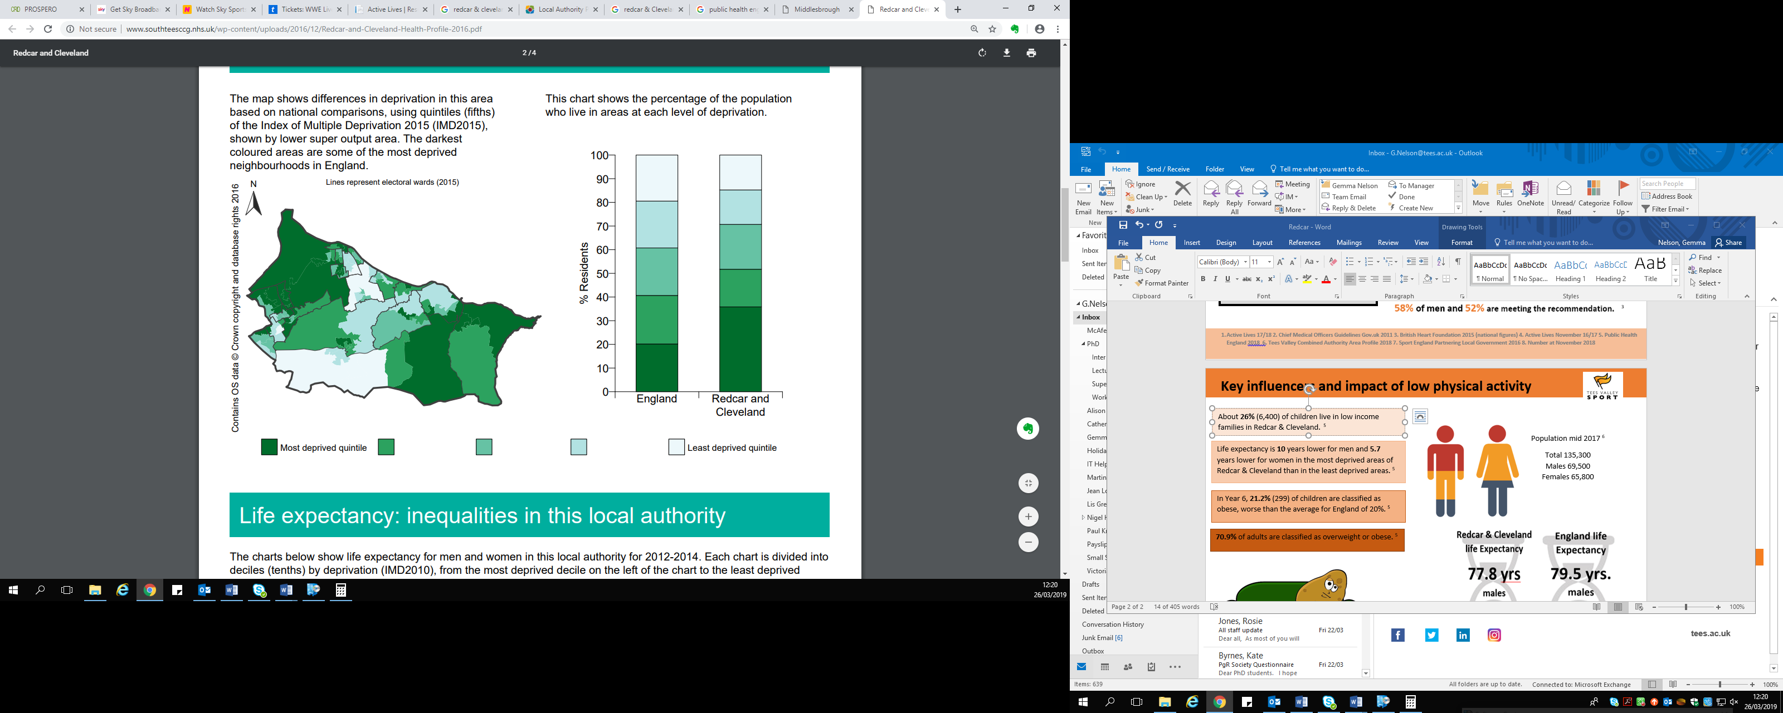

Top 5 most deprived areas in Redcar & Cleveland: 5

1. Grangetown
2. South Bank
3. Coatham
4. Kirkleatham
5. Eston

Redcar & Cleveland has 22 wards (small areas) that all hold a IMD score. 77% of Redcar & Cleveland has a score that places them in the bottom 10% of the most deprived areas in England. 14% of Redcar & Cleveland is in the bottom 1% of the most deprived areas. 5

**Deprivation:** The English indices of deprivation (IMD) measures relative deprivation in small areas. Total of 32,844 small areas in England, ranked based upon crime, health, income, employment, education etc. 5



