

**57.5%** adult population participate in more than 150 mins of physical activity each week. 1

**32.2%** adult population participate in less than 30 mins of physical activity each week. 1

**ACTIVE**

**10.4%** adult population participate in 30 to 149 mins of physical activity each week. 1

**FAIRLY ACTIVE**

**INACTIVE**

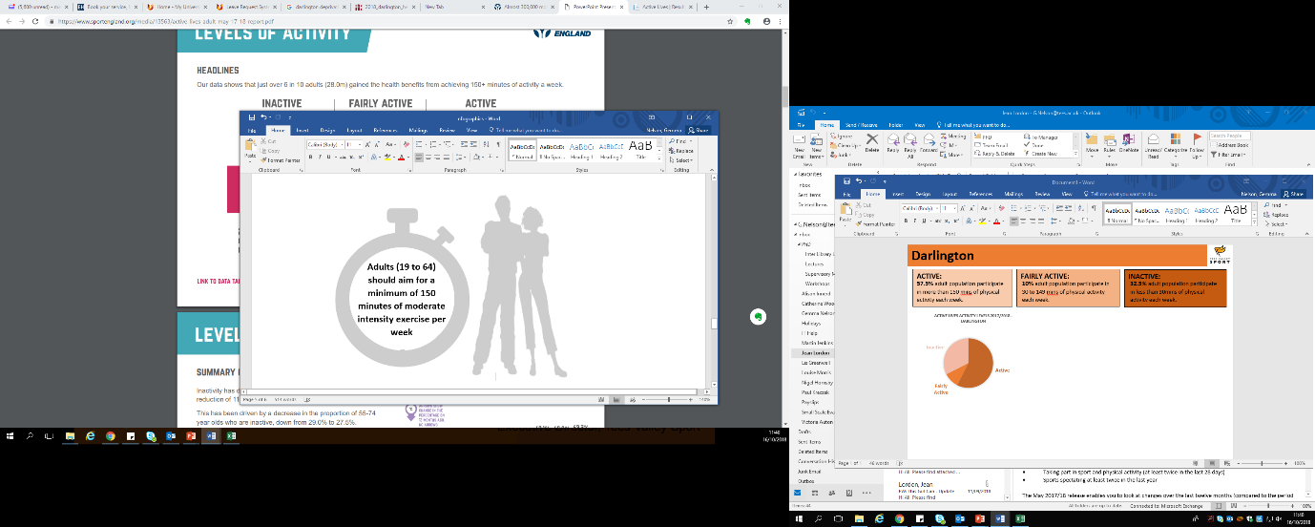

**16.3% of adults living in Middlesbrough have volunteered to support sport and physical activity at least twice in the last year (Nov 17/18) compared to 11.3% the previous year. 1**

32.2%

57.5%

10.4%

2

Adults doing more than 150 mins a week 1

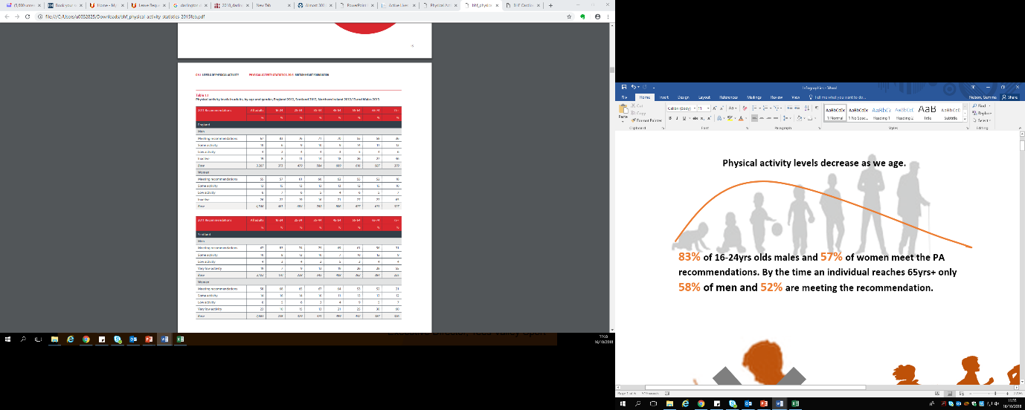

3

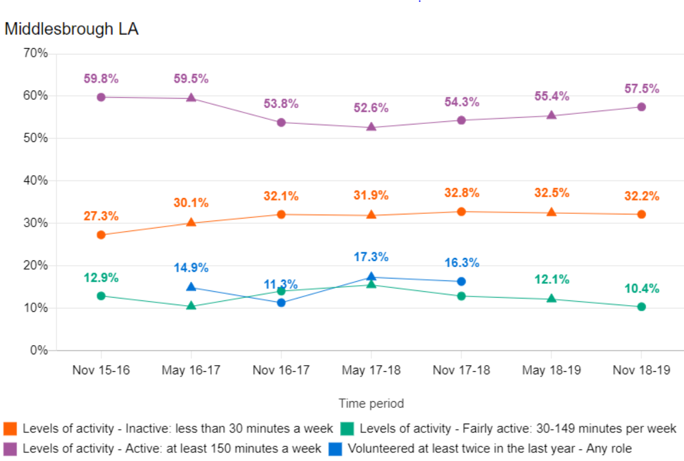

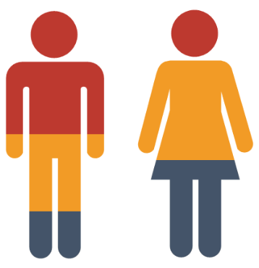

Population mid 2017 6

Total 140,600

Males 69,500

Females 71,100

Life expectancy is **12.5** years lower for men and **13** years lower for women in the most deprived areas of Middlesbrough than in the least deprived areas. 5

About **31%** (8,900) of children live in low income families in Middlesbrough.  5

**Key influencers and impact of low physical activity**

In Year 6, **22.7%** (401) of children are classified as obese, worse than the average for England of 20%. 5

**65.4%** of adults are classified as overweight or obese. 5

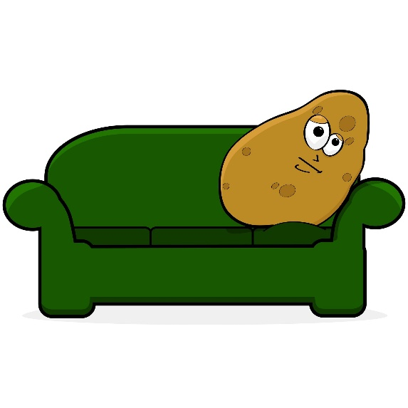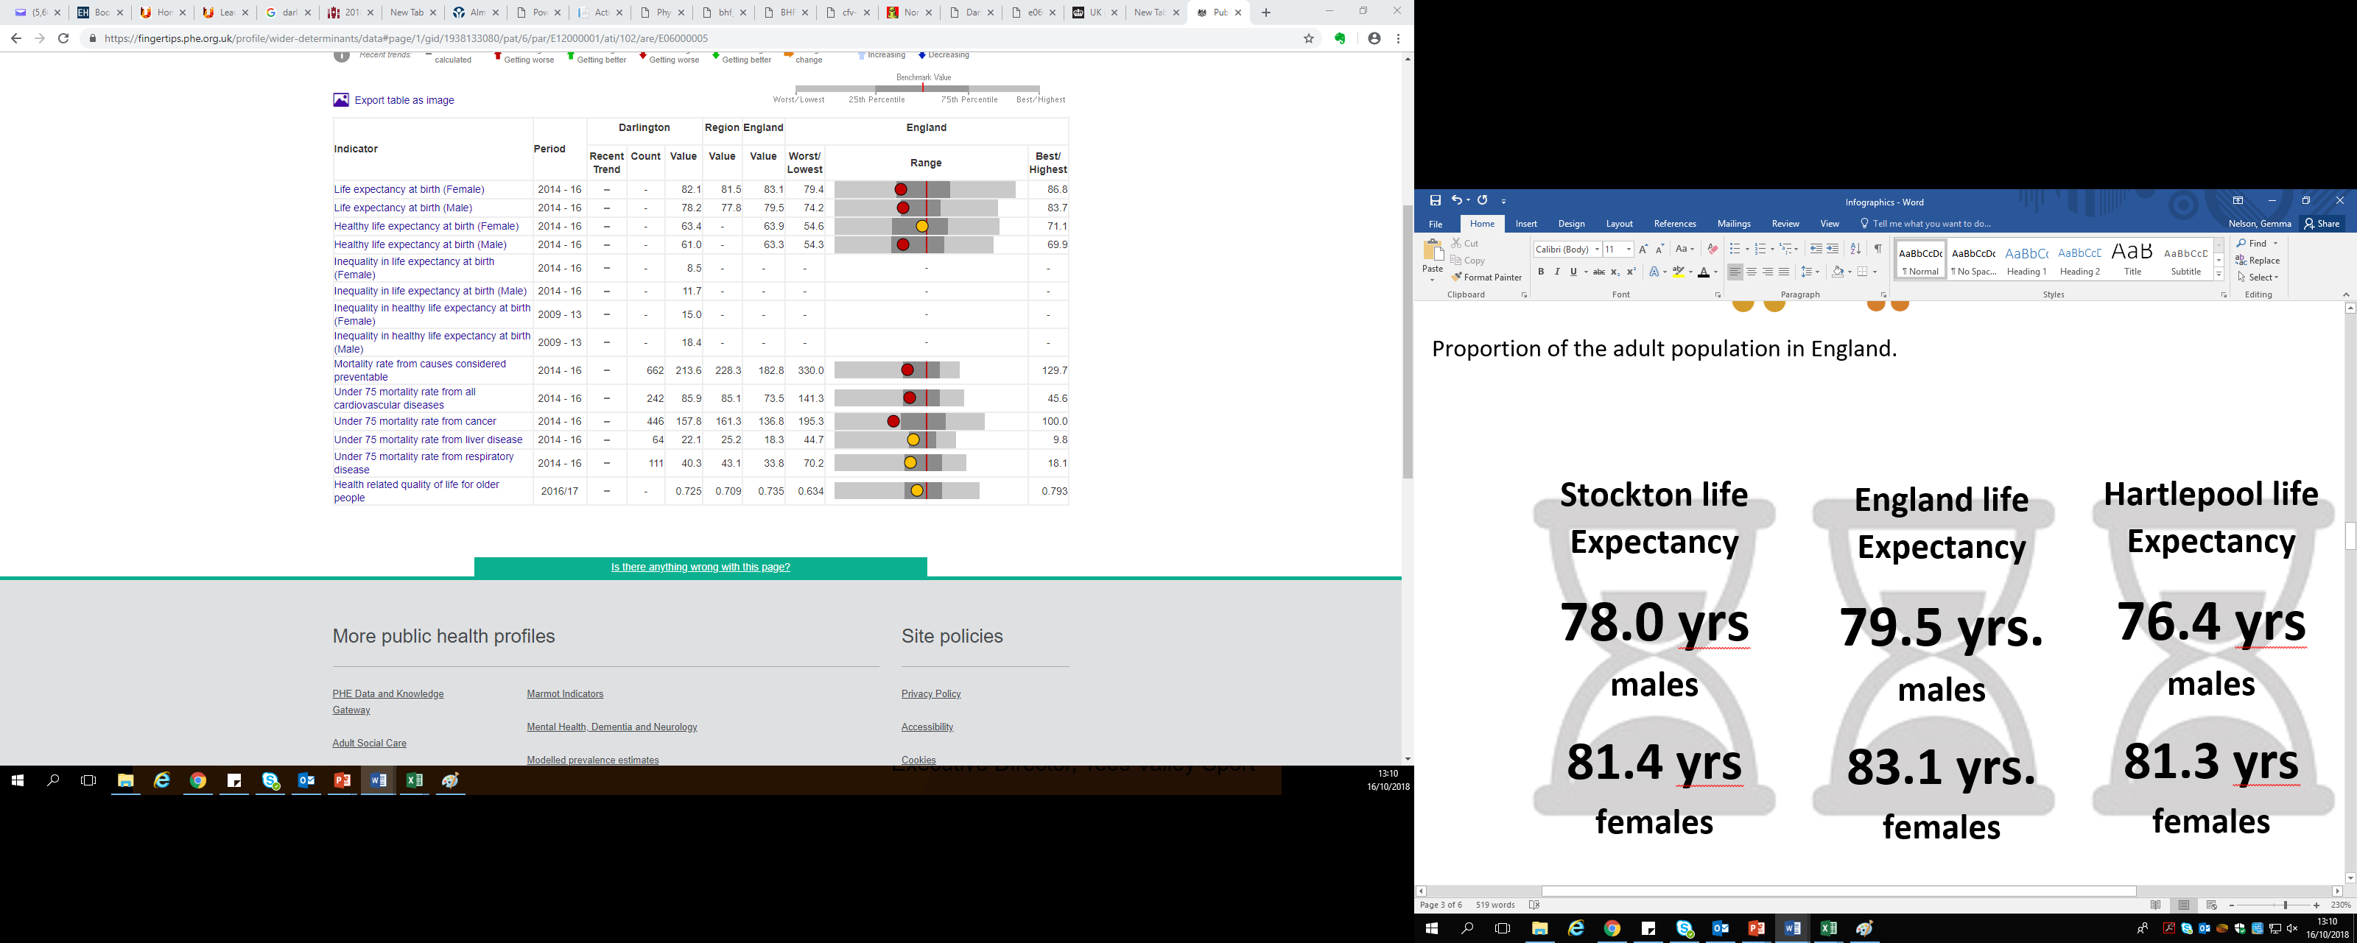

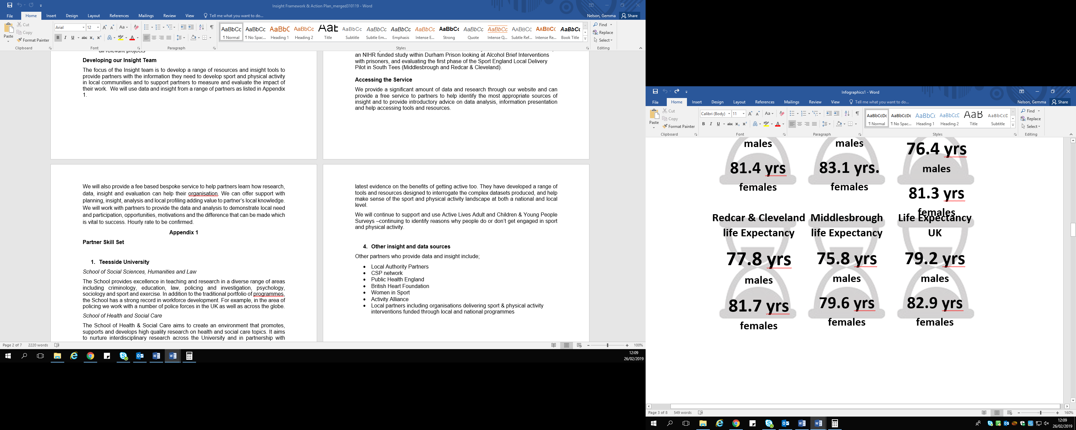

5

The unemployment claimant rate in September 2018 in Middlesbrough was 5% compared to the national rate of 2.2%. 6

The estimated health costs of physical inactivity is £2.4M 7



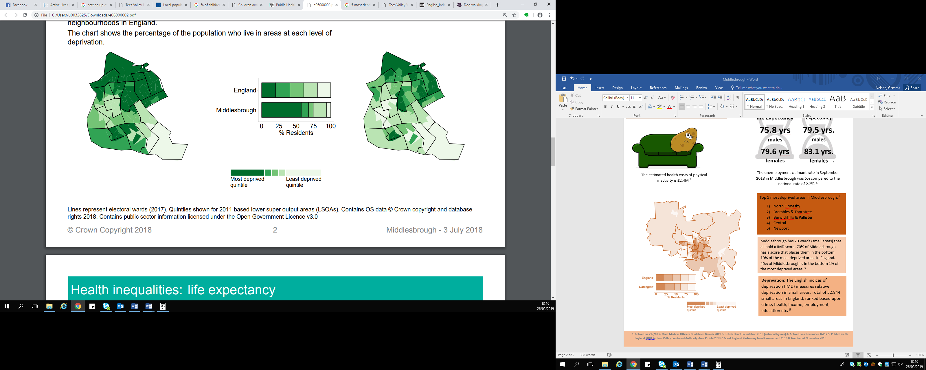

Top 5 most deprived areas in Middlesbrough: 5

1. North Ormesby
2. Brambles & Thorntree
3. Berwickhills & Pallister
4. Central
5. Newport

Middlesbrough has 20 wards (small areas) that all hold a IMD score. 70% of Middlesbrough has a score that places them in the bottom 10% of the most deprived areas in England. 40% of Middlesbrough is in the bottom 1% of the most deprived areas. 5





**Deprivation:** The English indices of deprivation (IMD) measures relative deprivation in small areas. Total of 32,844 small areas in England, ranked based upon crime, health, income, employment, education etc. 5